Directory File DICOM : DICOM/1.5T/week/all_series/

Select series number : 7

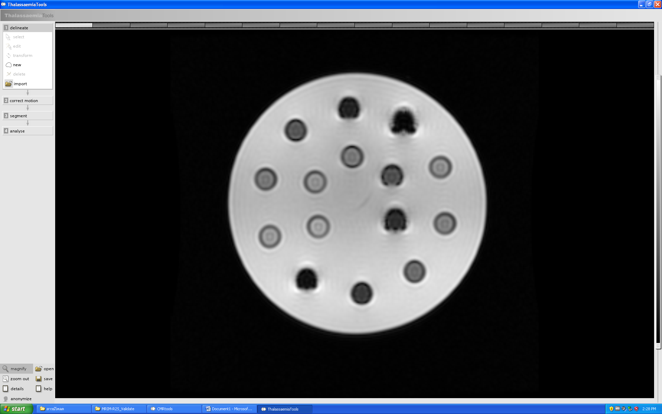

15

14

13

12

11

10

9

8

7

6

5

4

3

2

1

Zoom :

Delineate : draw ROI position order by top figure

Correct motion : -

Segment

Have 2 color -> green, red (no yellow)

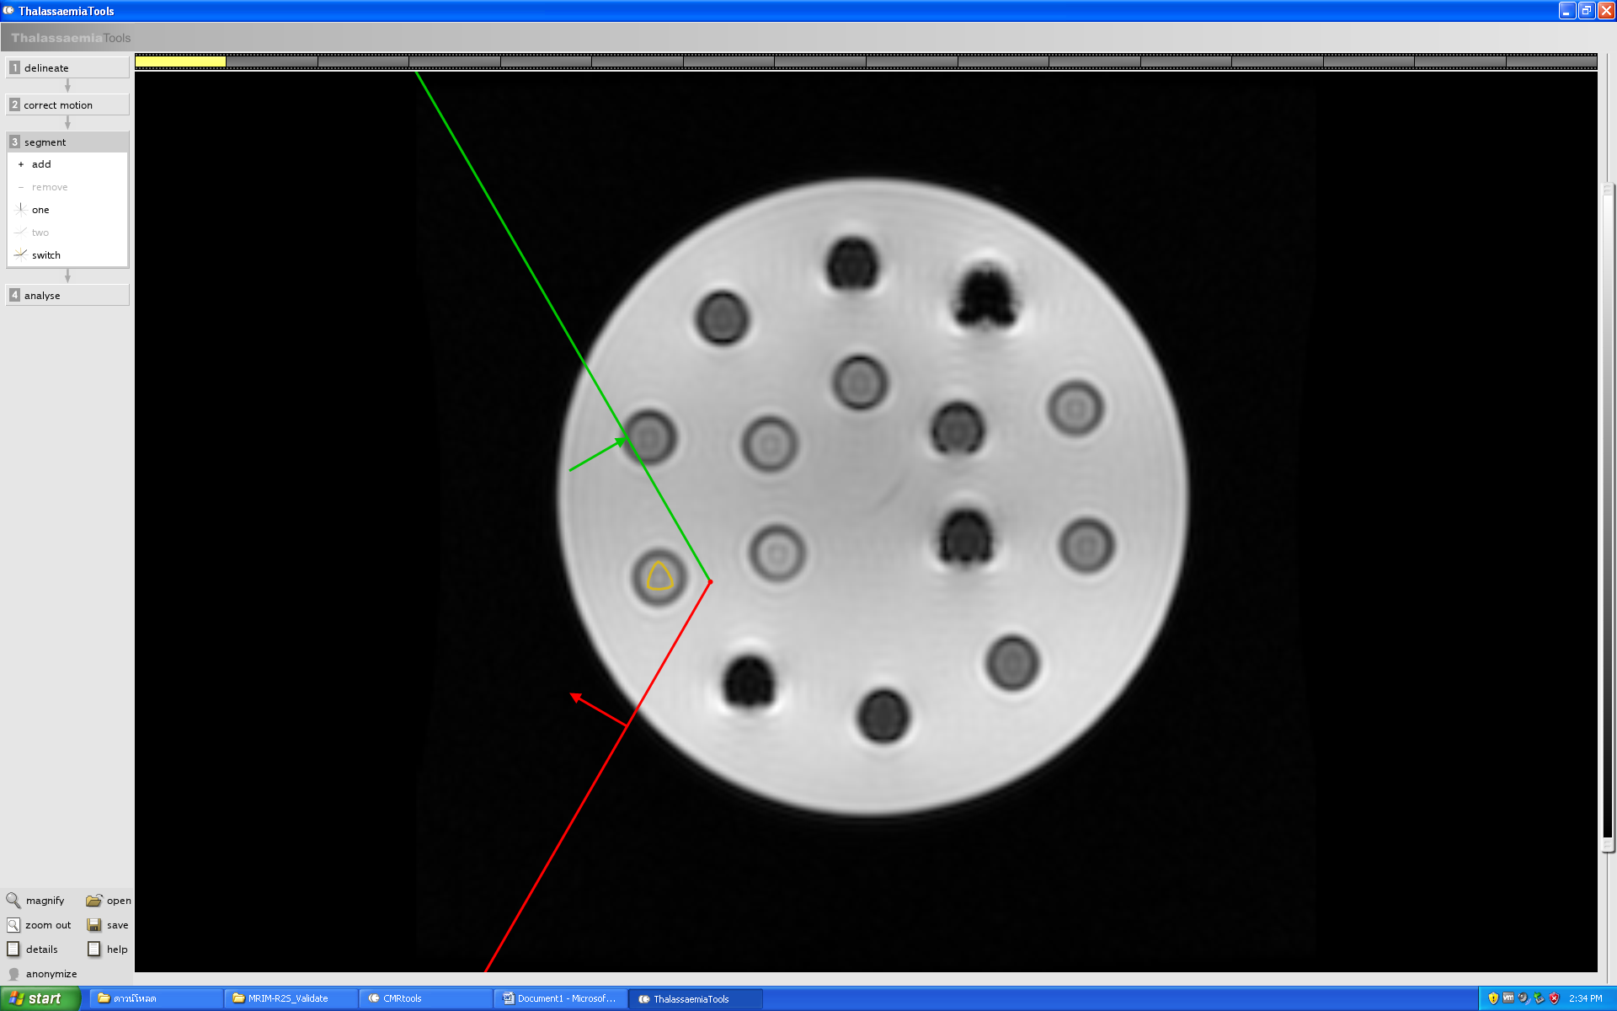

Analyse

* Zoom out
* Export to dcm
  + Save in :
  + File name: roi
  + Save as type: DICOM Image (*.dcm)
* Copy to clipboard
  + New File in Excel
  + paste
  + save file name: excel_roi
* save
  + File name: roi
  + Save as type: Thalassaemia Studies(*.TTS)